**Week 2**

**Roll No: 241801302**

**Name: Udhayakrishna K G**

**Week-02-01-Practice Session-Coding**

**Q1)** Many people think about their height in feet and inches, even in some countries that primarily use the metric system. Write a program that reads a number of feet from the user, followed by a number of inches. Once these values are read, your program should compute and display the equivalent number of centimeters.

Hint:

One foot is 12 inches.

 One inch is 2.54 centimeters.

 Input Format

 First line,read the number of feet.

 Second line, read the number of inches.

Output Format

In one line print the height in centimeters.

 Note: All of the values should be displayed using two decimal places.

Sample Input 1

 5 6

Sample Output 1

 167.64

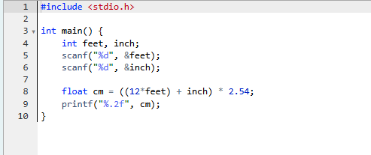

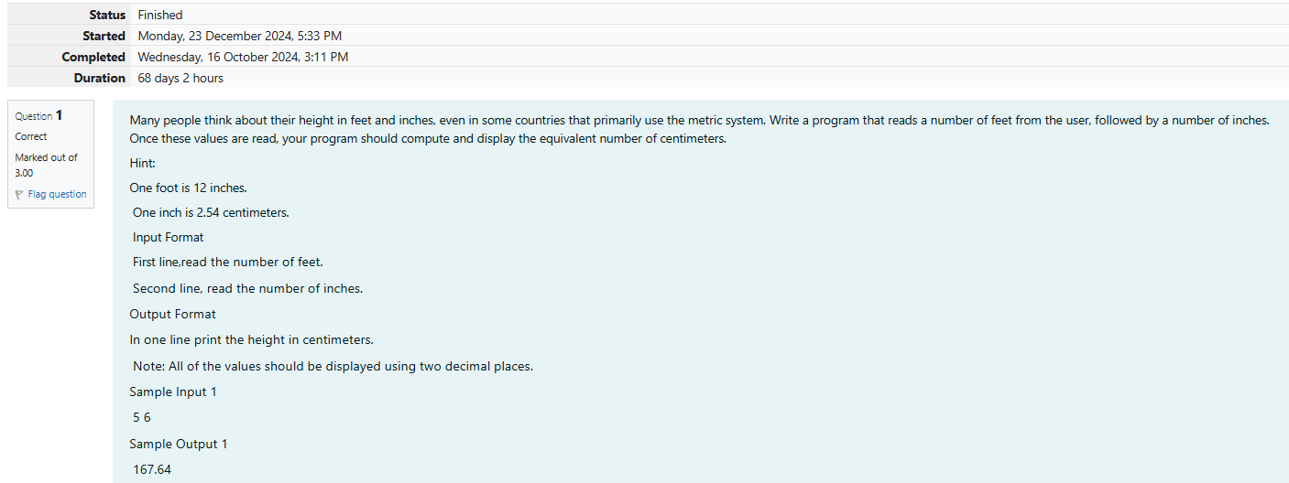

Output:

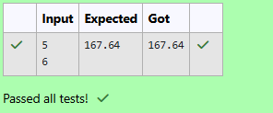

**Q2)** Create a program that reads two integers, a and b, from the user. Your program should compute and display: • The sum of a and b • The difference when b is subtracted from a • The product of a and b • The quotient when a is divided by b • The remainder when a is divided by b

Input Format

First line, read the first number.

 Second line, read the second number.

Output Format

First line, print the sum of a and b

Second line, print the difference when b is subtracted from a

Third line, print the product of a and b

Fourth line, print the quotient when a is divided by b

Fifth line, print the remainder when a is divided by b

Sample

Input 1 100 6

Sample Output

106 94 600 16 4

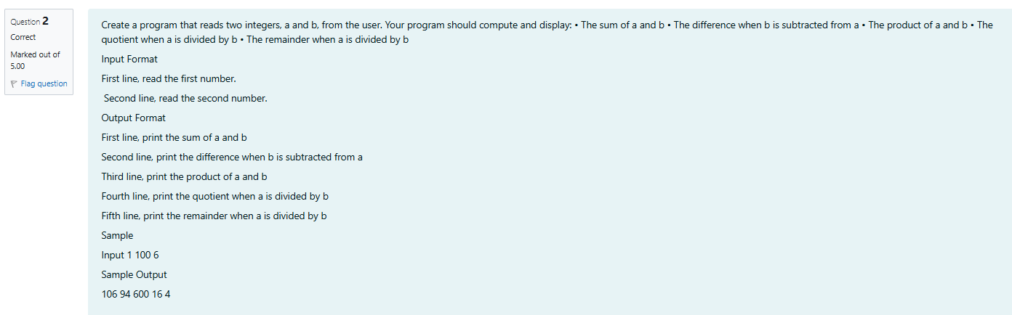

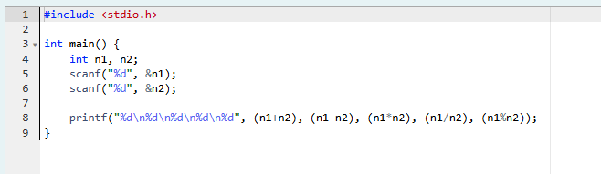

**Ouput:**

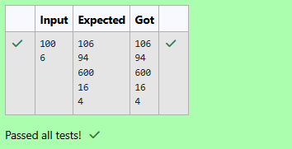

**Q3)** A bakery sells loaves of bread for $3.49 each. Day old bread is discounted by 60 percent. Write a program that begins by reading the number of loaves of day old bread being purchased from the user. Then your program should display the regular price for the bread, the discount because it is a day old, and the total price. Each of these amounts should be displayed on its own line with an appropriate label. All of the values should be displayed using two decimal places.

Input Format

Read the number of day old loaves.

 Output Format

 First line, print Regular price: price

 Second line, print Discount: discount

Third line, print Total: total

Note: All of the values should be displayed using two decimal places.

 Sample Input 1

10

Sample Output 1

Regular price: 34.90

Discount: 20.94

Total: 13.96

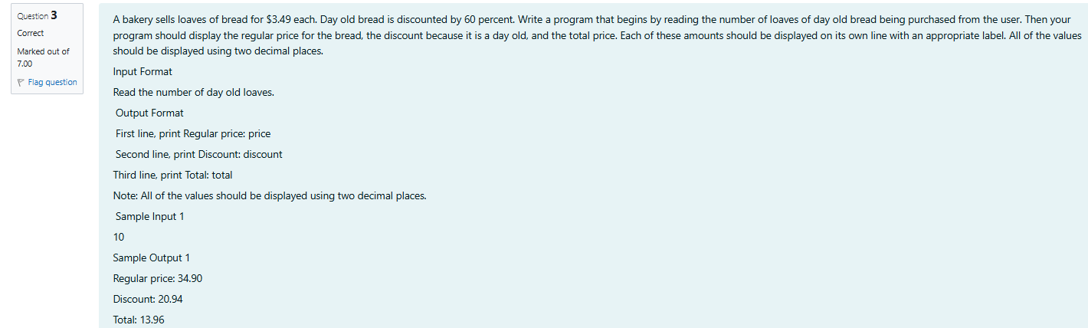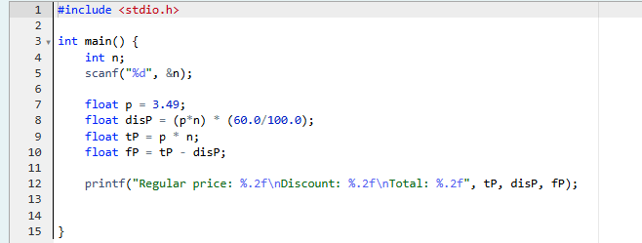

**Output:**

**Week-02-02-Practice Session-Coding**

Q1) Goki recently had a breakup, so he wants to have some more friends in his life. Goki has N people who he can be friends with, so he decides to choose among them according to their skills set Yi(1<=i<=n). He wants atleast X skills in his friends. Help Goki find his friends. ________________________________________

 INPUT

First line contains a single integer X - denoting the minimum skill required to be Goki's friend. Next line contains one integer Y - denoting the skill of the person

. ________________________________________

OUTPUT

 Print if he can be friend with Goki. 'YES' (without quotes) if he can be friends with Goki else 'NO' (without quotes).

 ________________________________________

 CONSTRAINTS

1<=N<=1000000

1<=X,Y<=1000000

SAMPLE INPUT 1

 100 110

 SAMPLE OUTPUT 1

YES

SAMPLE INPUT 2

 100 90

 SAMPLE OUTPUT 2

NO

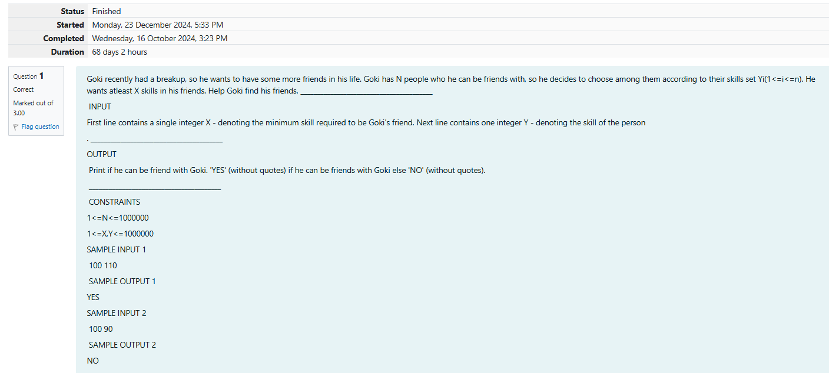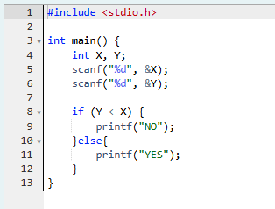

**Output:**

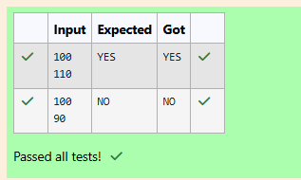

Q2) Before the outbreak of corona virus to the world, a meeting happened in a room in Wuhan. A person who attended that meeting had COVID-19 and no one in the room knew about it! So everyone started shaking hands with everyone else in the room as a gesture of respect and after meeting unfortunately everyone got infected! Given the fact that any two persons shake hand exactly once, Can you tell the total count of handshakes happened in that meeting? Say no to shakehands. Regularly wash your hands. Stay Safe.

Input Format

Read an integer N,the total number of people attended that meeting.

Output Format

Print the number of handshakes.

Constraints

0 < N < 106

SAMPLE INPUT 1

 1

SAMPLE OUTPUT

0

SAMPLE INPUT 2

 2

SAMPLE OUTPUT 2

1

Explanation Case 1: The lonely board member shakes no hands, hence 0. Case 2: There are 2 board members, 1 handshake takes place.

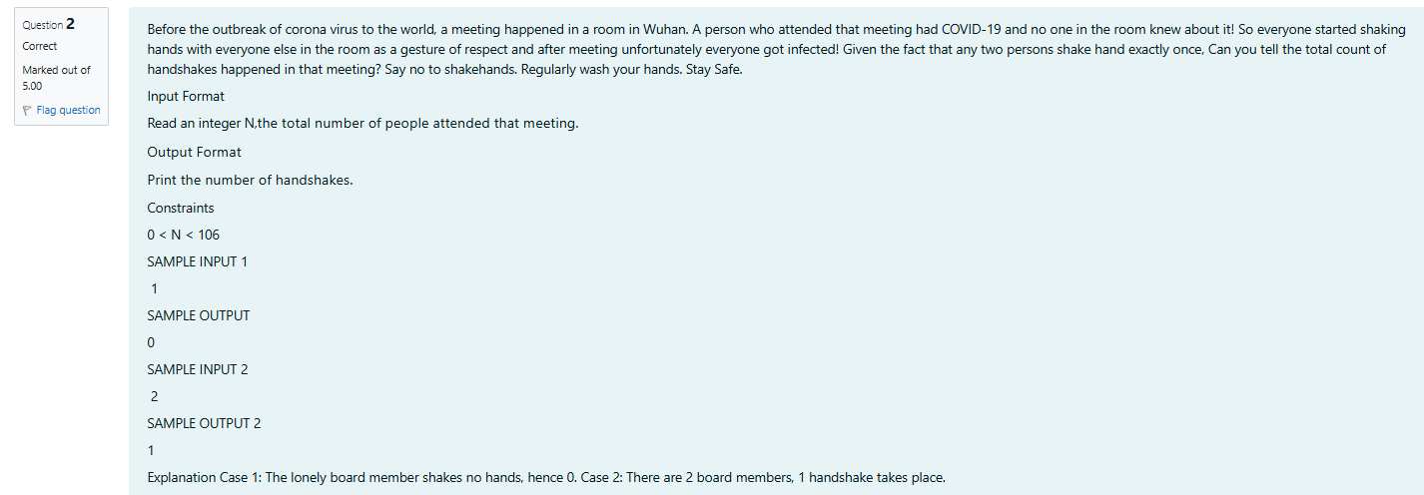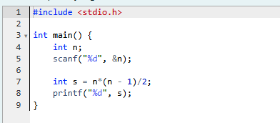

**Output:**

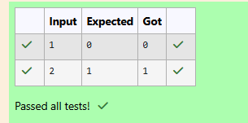

Q3) In our school days, all of us have enjoyed the Games period. Raghav loves to play cricket and is Captain of his team. He always wanted to win all cricket matches. But only one last Games period is left in school now. After that he will pass out from school. So, this match is very important to him. He does not want to lose it. So he has done a lot of planning to make sure his teams wins. He is worried about only one opponent - Jatin, who is very good batsman. Raghav has figured out 3 types of bowling techniques, that could be most beneficial for dismissing Jatin. He has given points to each of the 3 techniques. You need to tell him which is the maximum point value, so that Raghav can select best technique. 3 numbers are given in input. Output the maximum of these numbers.

Input:

Three space separated integers.

Output:

Maximum integer value

SAMPLE INPUT

 8 6 1

SAMPLE OUTPUT

 8

Explanation Out of given numbers, 8 is maximum.

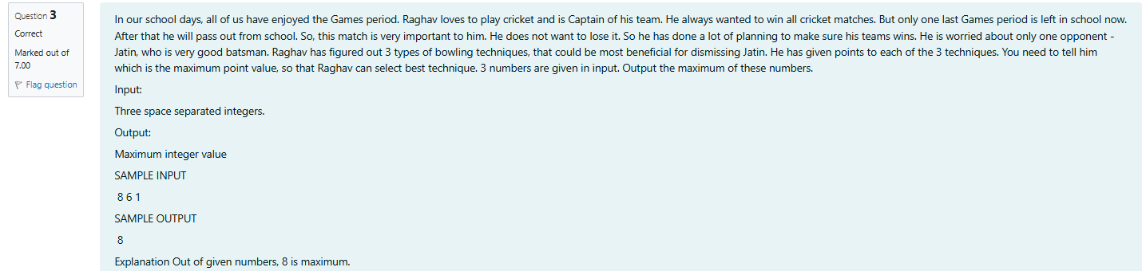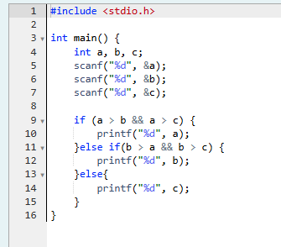

**Output:**

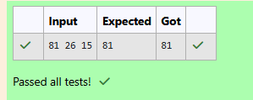

## **Coding-Variables and Keywords**

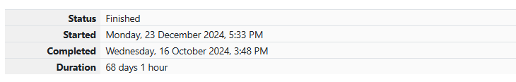

Q1) Read the code given below to learn naming conventions in identifiers.  
  
For example, consider the program given below:

#include <**stdio.h**>

**int** main()

{

**int** age = 2; // age is an integer variable

**int** firstNumber = 2; // firstNumber is an integer variable

// If there are two or more words in an identifier/variable - User can also use "camel case" style to declare a variable.

**int** second_number = 3; // second_number is an integer variable

// Any space cannot be used between two words of an identifier/variable; User can use underscore (_) instead of space.

**int** _i_am_also_a_valid_identifier = 4; // _i_am_also_a_valid_identifier is an integer variable

// An identifier/variable name must be start with an alphabet or underscore (_) only, no other special characters, digits are allowed as first character of the identifier/variable name.

printf("age = %d\n", age);

printf("firstNumber = %d\n", firstNumber);

printf("second_number = %d\n", second_number);

printf("_i_am_also_a_valid_identifier = %d\n", _i_am_also_a_valid_identifier);

return 0;

}

Fill in the missing code in the below program to print the values of the given variables. 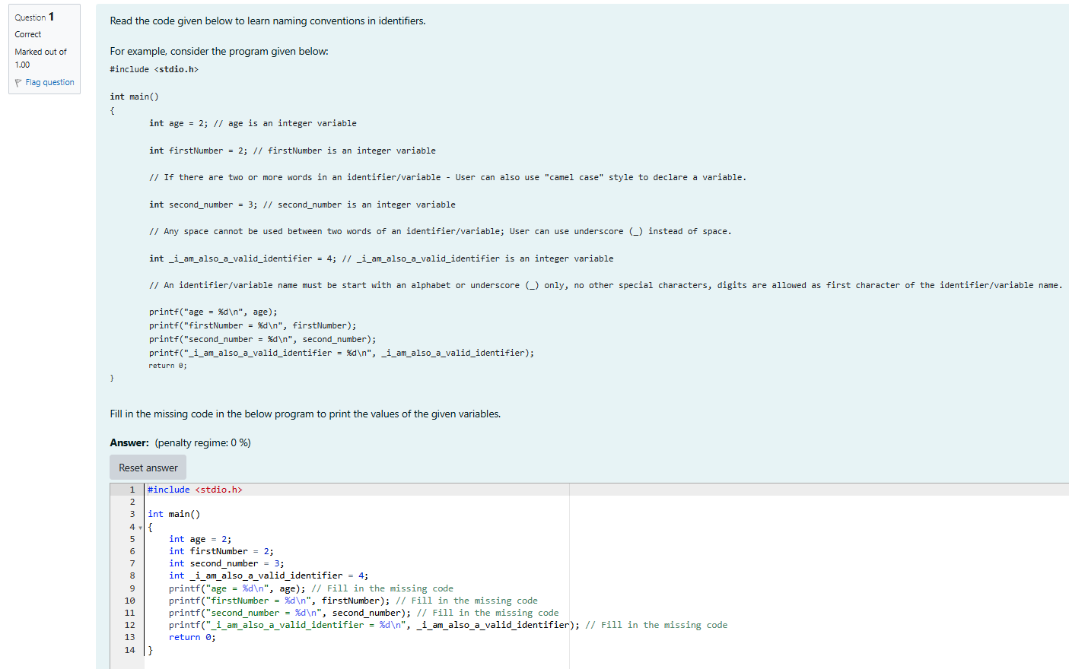

**Output:**

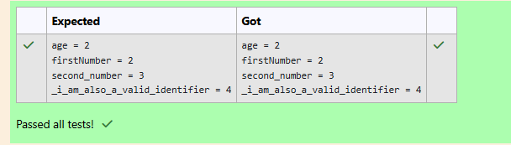

## **Coding-Syntax of main() function**

Q1) Identify and correct the error in the code given below.

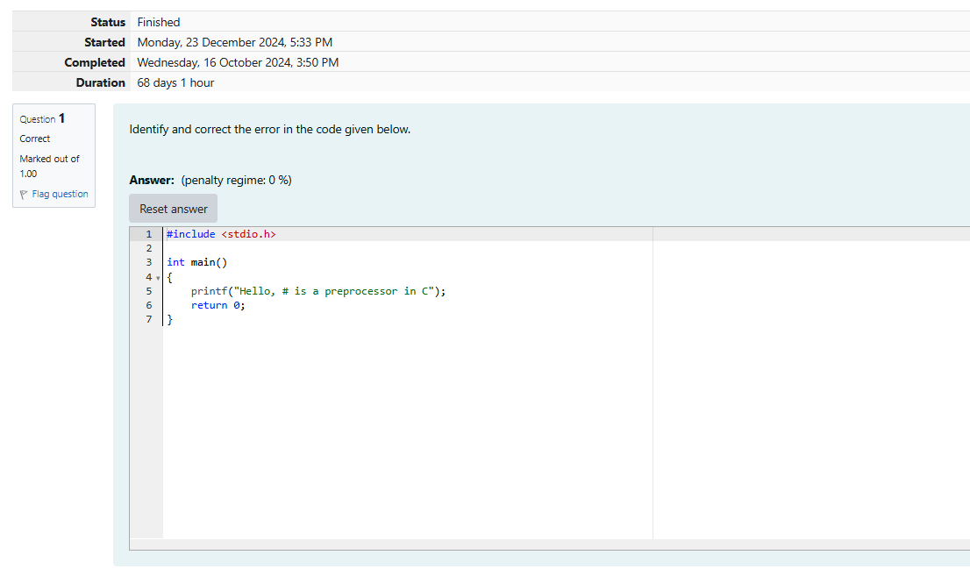

**Output:**

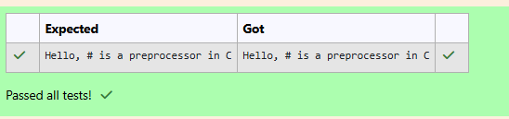

Q2) In **C** programming language, execution of the code starts with a [function](https://en.wikipedia.org/wiki/Subroutine) called main.  
  
We shall learn more about functions in the later sections. For now, we can safely assume that **function** is the name given to a set of one or more executable statements. main() is a **user defined function**, i.e., a user (a programmer) writes the code for the main() function.  
  
While executing a **C** program, the **Operating System (OS)** only calls the main() function in that program.  
  
When the **OS** executes a program, the program usually returns an integer value 0 if the execution of that program is successful.  
  
In **C**, **main()** can be written in such a way that it returns a an int.

**#include <stdio.h>**

**int main()**

**{**

printf("Sample main() function with int as return type!");

return 0;// 0 value indicates that the execution is successful

**}**

If the programmer does not specify any return type, the return type is by default considered as int.  
  
The name of the main() function should always be in lowercase, i.e., if a function is written as Main(), it is not the main function which is called by the OS.  
  
Read the code given below to familiarize yourself with the syntax of main() function. Retype in the space provided.

#include <stdio.h>  
  
int main()  
{  
    printf("Impossible is nothing!");  
    return 0;  
}

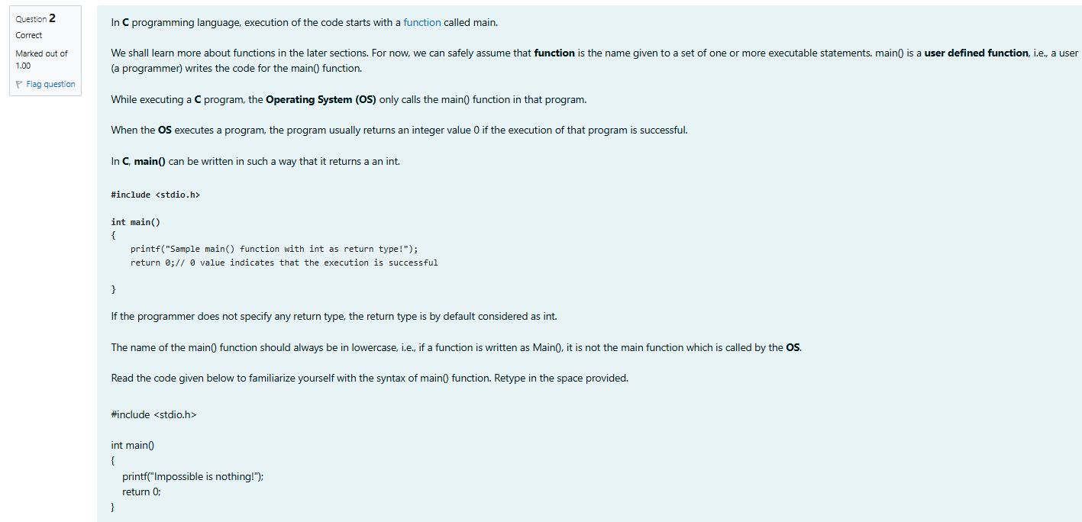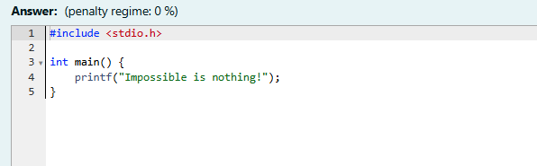

**Output:**

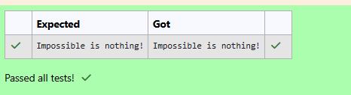

Q3) Identify and correct the error in the code given below.

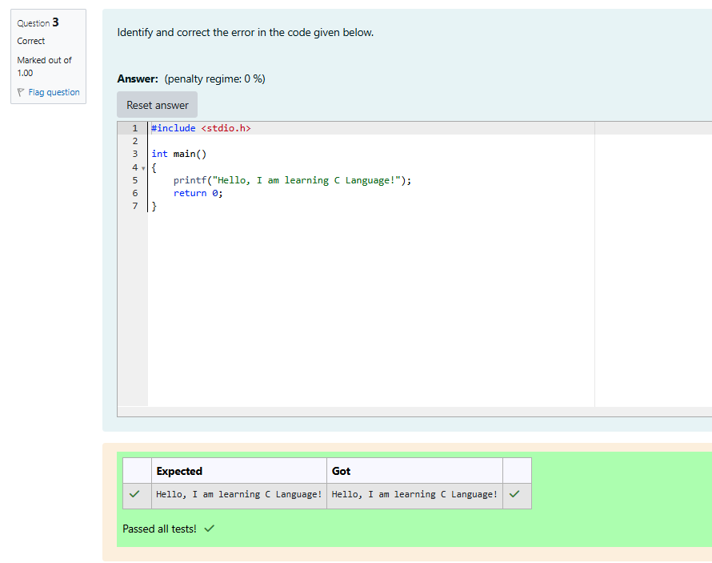

Q4) Click on Check without correcting the code.  
  
This results in many errors because the main function is not defined correctly.  
  
Now, correct the spelling of the main function and submit the program once again.

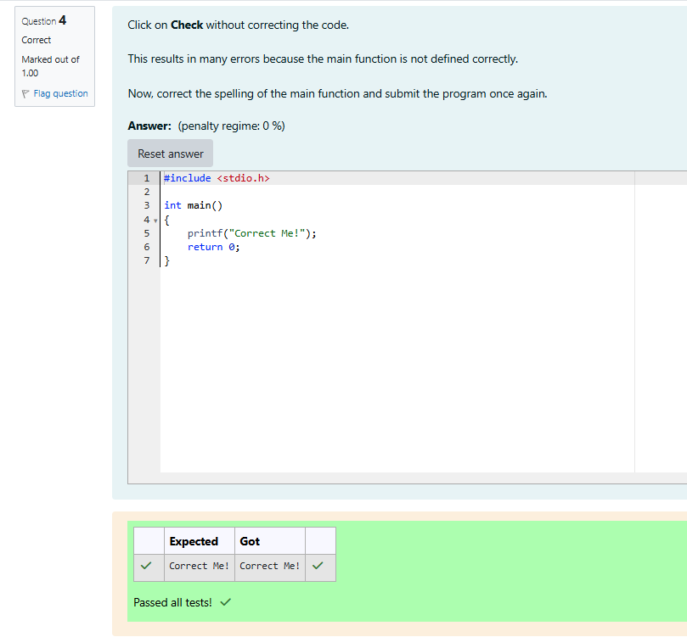

Q5) Identify and correct the error in the code given below.

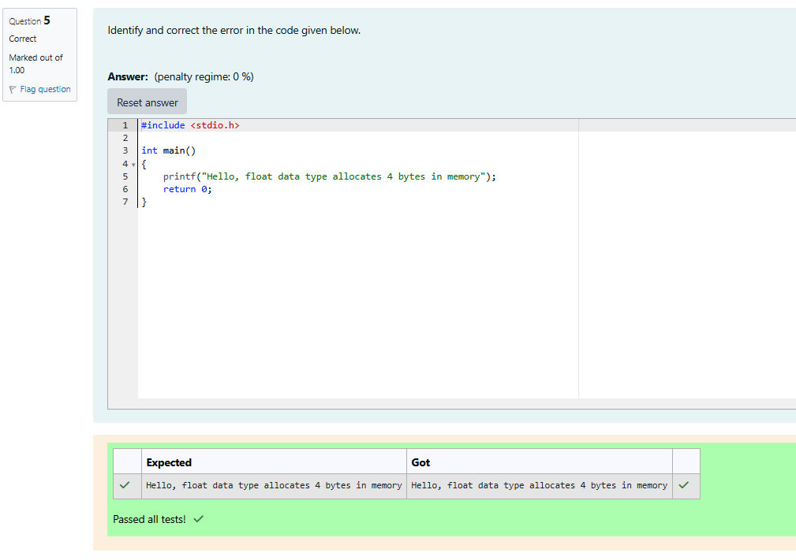

## **int Data Type**

Q1) In the program given below, we shall learn how to assign values to int data type from binary, octal, hex and character literals.  
  
Read the code given below and retype in the space provided.

#include <stdio.h>

int main()

{

    int binaryThree = 0b11;

    printf("binaryThree value = %d\n", binaryThree);

    int octalEight = 010;

    printf("octalEight value = %d\n", octalEight);

    int hexTen = 0xA;

    printf("hexTen value = %d\n", hexTen);

    int asciiValueOfOne = '1';

    printf("asciiValueOfOne value = %d\n", asciiValueOfOne);

    int asciiValueOfA = 'A';

    printf("asciiValueOfA value = %d\n", asciiValueOfA);

    return 0;

}

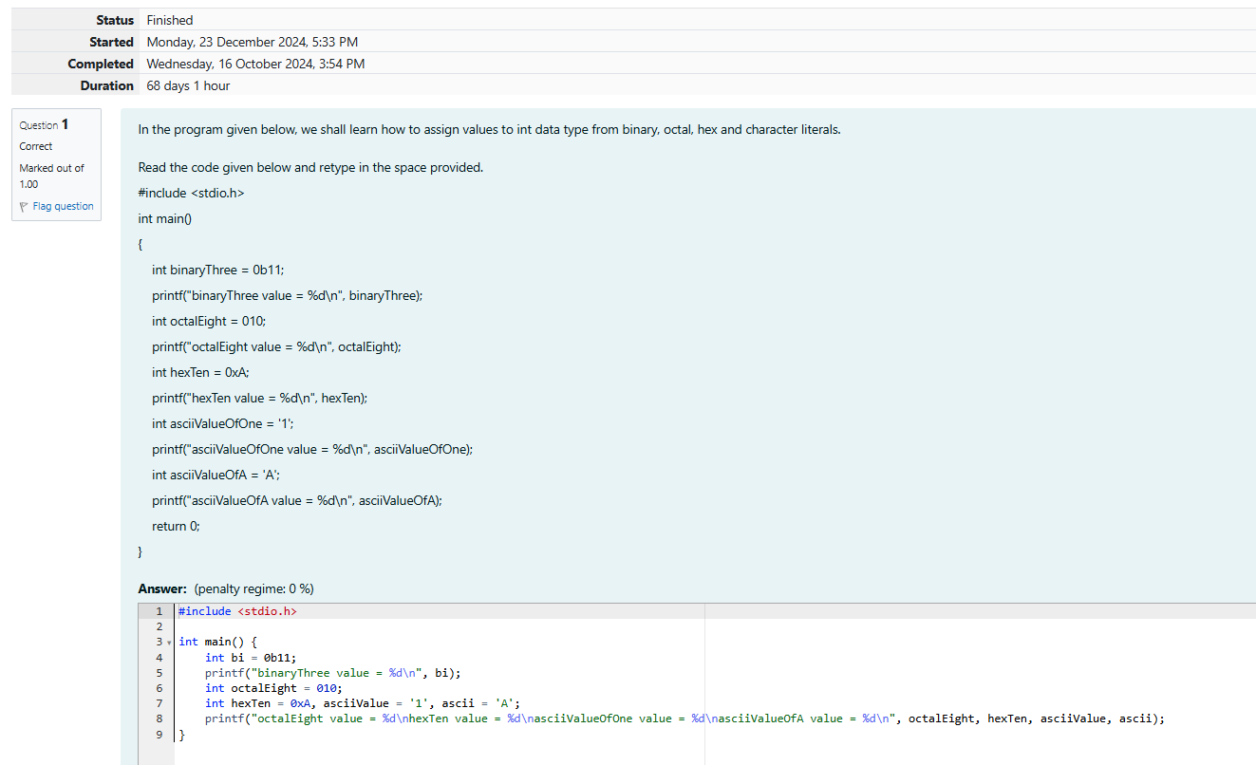

**Output:**

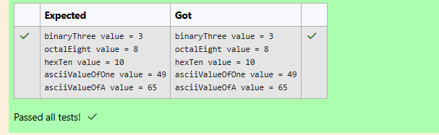

Q2) In the program given below, fill in the missing code to add two integer numbers.  
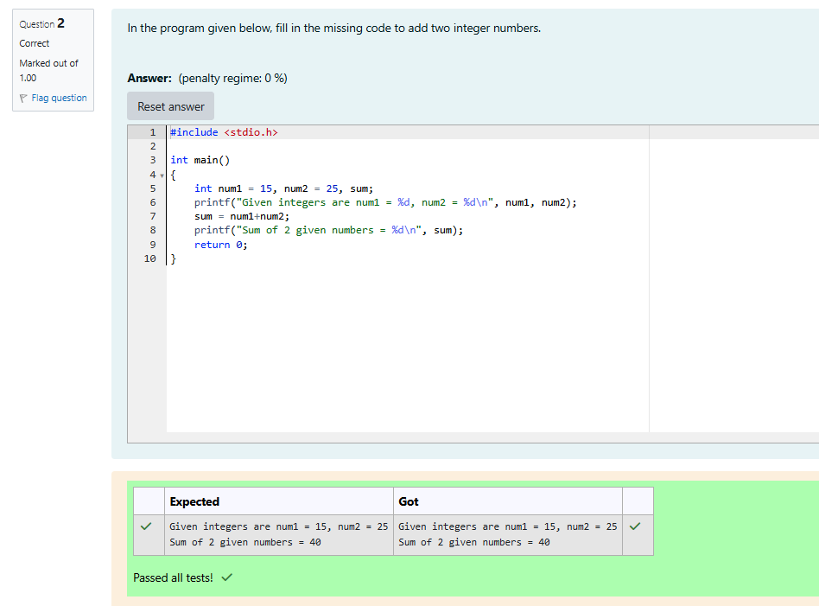

Q3) To print unsigned values on the console, use %u format character instead of %d in the **printf()** function.  
  
Whenever an attempt is made to assign a negative number to an **unsigned int** ( For eg: unsigned int num = -1;) the compiler does not flag it as an **error**. Instead, it will automatically convert the negative number to a positive number as shown below:

unsigned int **num** = -1;

The value stored in **num** = unsigned int **maximum_value** + **1** - **num**;

The final value in **num** = 4294967295 (in a 32-bit processing system)

In the program given below, fill in the missing format characters to print signed and unsigned values. 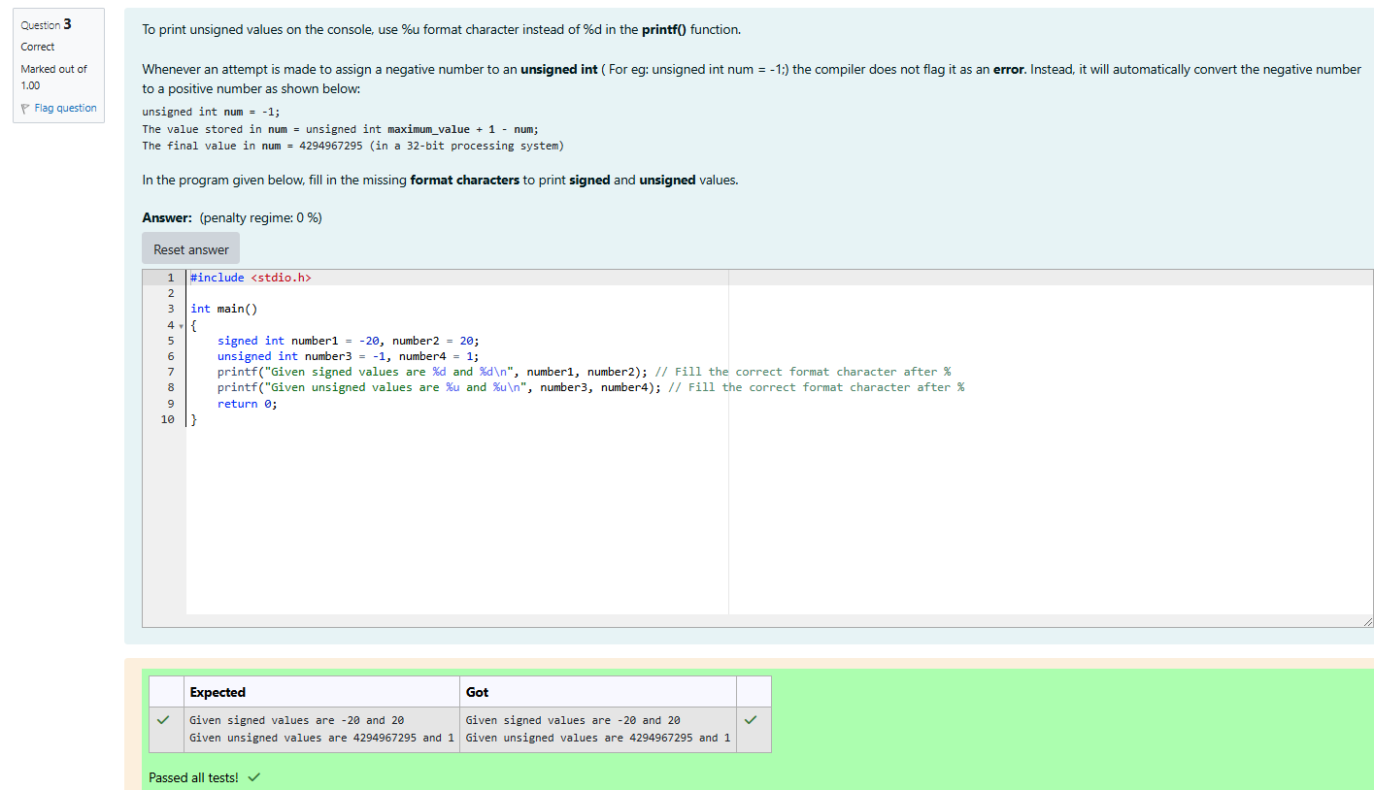

Q4) Identify the error and correct the code. [**Hint**: Verify if all variables are declared before they are first used.]

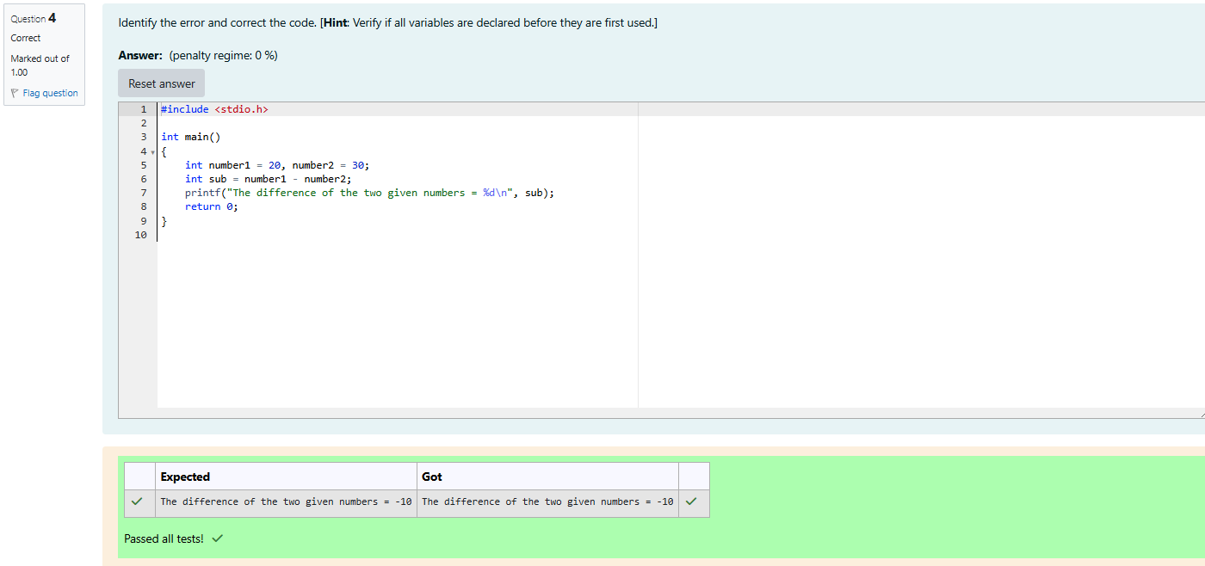

## **float Data Type**

Q1)Identify and correct the errors in the code given below:

Expected Output:

Given float values are num1 = 5.340000, num2 = 125.789001  
The result after dividing in float format = 23.555992  
The result after dividing in exponential format = 2.355599e+01

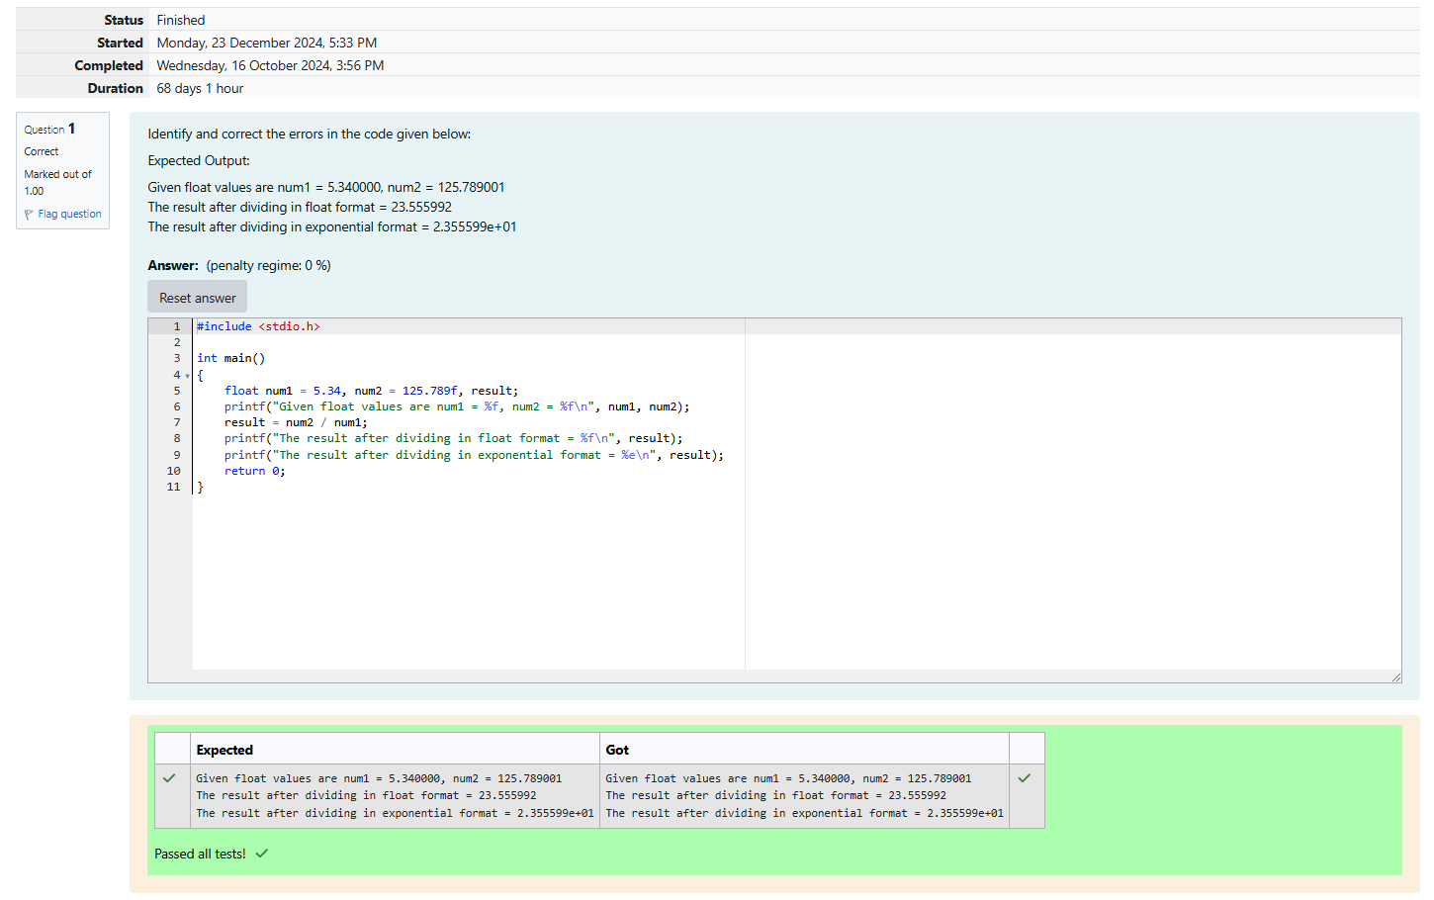

Q2) Identify and correct the errors in the code given below:

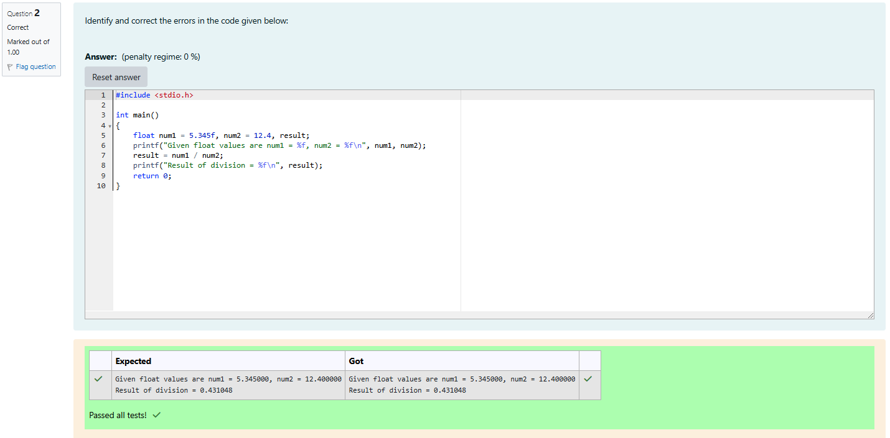

## **Cricket Stadium**

Q1)There was a large ground in center of the city which is rectangular in shape. The Corporation decides to build a Cricket stadium in the area for school and college students, But the area was used as a car parking zone. In order to protect the land from using as an unauthorized parking zone, the corporation wanted to protect the stadium by building a fence. In order to help the workers to build a fence, they planned to place a thick rope around the ground. They wanted to buy only the exact length of the rope that is needed. They also wanted to cover the entire ground with a carpet during rainy season. They wanted to buy only the exact quantity of carpet that is needed. They requested your help. Can you please help them by writing a program to find the exact length of the rope and the exact quantity of carpet that is required?

Input format:

Input consists of 2 integers. The first integer corresponds to the length of the ground and the second integer corresponds to the breadth of the ground.

Output Format:

Output Consists of two integers. The first integer corresponds to the length. The second integer corresponds to the quantity of carpet required.

Sample Input:

50

20

Sample Output:

140

1000

For example:

| Input | Result |
| --- | --- |
| 50  20 | 140  1000 |

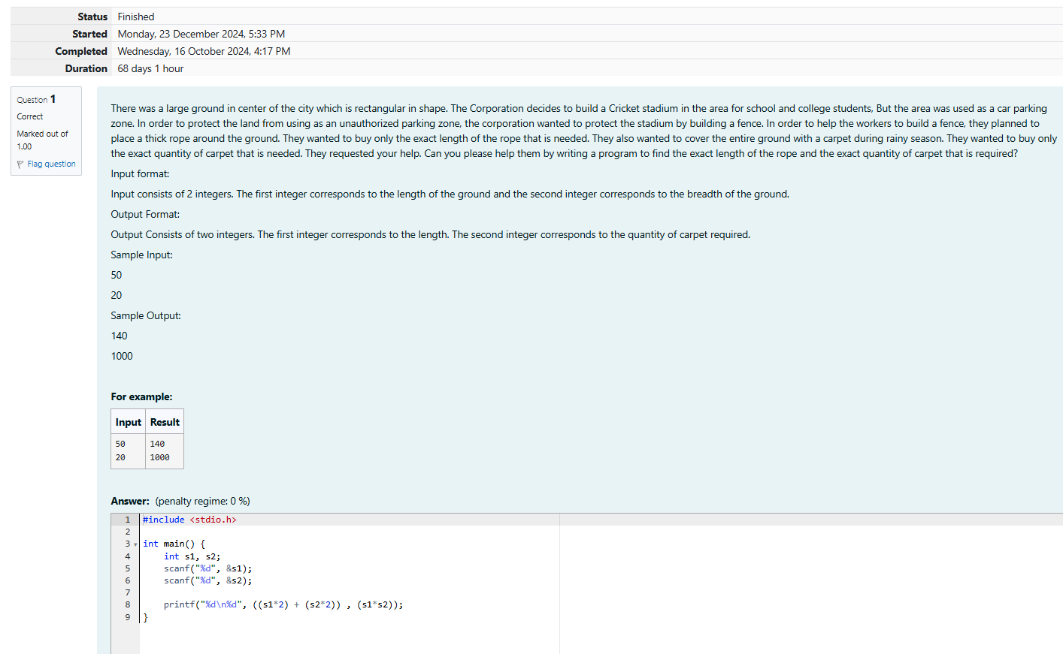

**Output:**

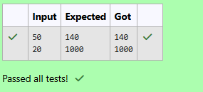

## **Sports Day Celebration**

Q1)Training for sports day has begun and the physical education teacher has decided to conduct some team games. The teacher wants to split the students in higher secondary into equal sized teams. In some cases, there may be some students who are left out from the teams and he wanted to use the left out students to assist him in conducting the team games. For instance, if there are 50 students in a class and if the class has to be divided into 7 equal sized teams, 7 students will be there in each team and 1 student will be left out. That 1 student will assist the PET. With this idea in mind, the PET wants your help to automate this team splitting task. Can you please help him out?

INPUT FORMAT:

Input consists of 2 integers. The first integer corresponds to the number of students in the class and the second integer corresponds to the number of teams.

OUTPUT FORMAT:

The output consists of two integers. The first integer corresponds to the number of students in each team and the second integer corresponds to the students who are left out.

SAMPLE INPUT:

60

8

SAMPLE OUTPUT:

7

4

For example:

| Input | Result |
| --- | --- |
| 60  8 | 7  4 |

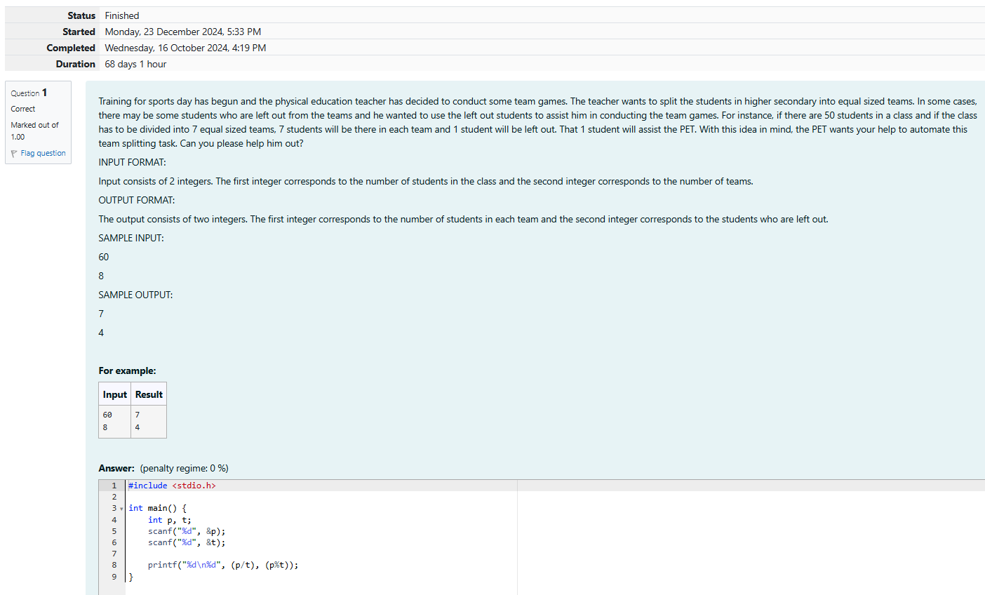

Output:

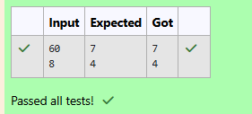

## **The Newspaper Agency**

Q1) Each Sunday, a newspaper agency sells w copies of a special edition newspaper for Rs.x per copy. The cost to the agency of each newspaper is Rs.y. The agency pays a fixed cost for storage, delivery and so on of Rs.100 per Sunday. The newspaper agency wants to calculate the profit which it obtains only on Sundays. Can you please help them out by writing a program to compute the profit if w, x, and y are given?

INPUT FORMAT:

Input consists of 3 integers: w, x, and y. w is the number of copies sold, x is the cost per copy and y is the cost the agency spends per copy.

OUTPUT FORMAT:

The output consists of a single integer which corresponds to the profit obtained by the newspaper agency.

SAMPLE INPUT:

1000

2

1

SAMPLE OUTPUT:

900

For example:

| Input | Result |
| --- | --- |
| 1000  2  1 | 900 |

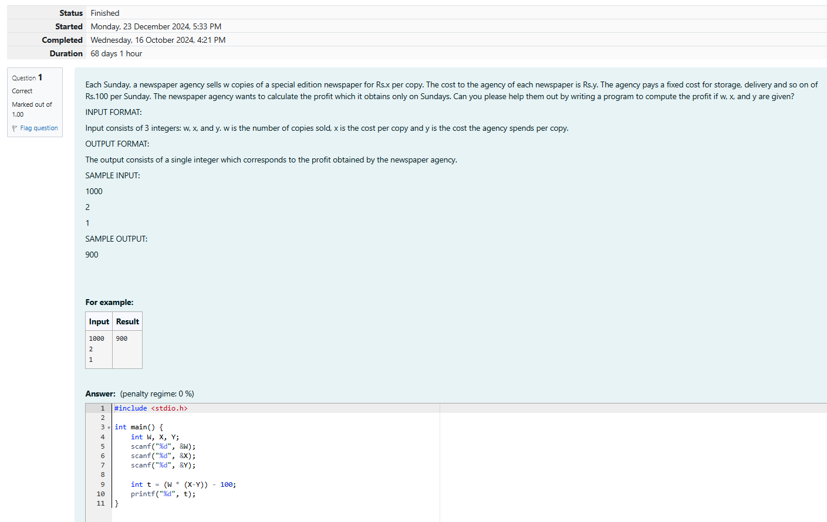

**Output:**

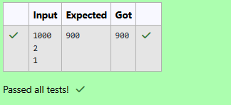

## **The Chronicles of Narnia**

Q1) Four kids Peter, Susan, Edmond and Lucy travel through a wardrobe to the land of Narnia. Narnia is a fantasy world of magic with mythical beasts and talking animals.While exploring the land of narnia Lucy found Mr.Tumnus the two legged stag ,and she followed it, down a narrow path .She and Mr.Tumnus became friends and he offered a cup of coffee to Lucy in his small hut.It was time for Lucy to return to her family and so she bid good bye to Mr.Tumnus and while leaving Mr.Tumnus told that it is quite difficult to find the route back as it was already dark. He told her to see the trees while returning back and said that the first tree with two digits number will help her find the way and the way to go back to her home is the sum of digits of the tree and that numbered way will lead her to the tree next to the wardrobe where she can find the others. Lucy was already confused, so please help her in finding the route to her home....

Input Format:

Input consists of an integer corresponding to the 2-digit number.

Output Format:

Output consists of an integer corresponding to the sum of its digits.

SAMPLE INPUT:

87

SAMPLE OUTPUT:

15

For example:

| Input | Result |
| --- | --- |
| 87 | 15 |

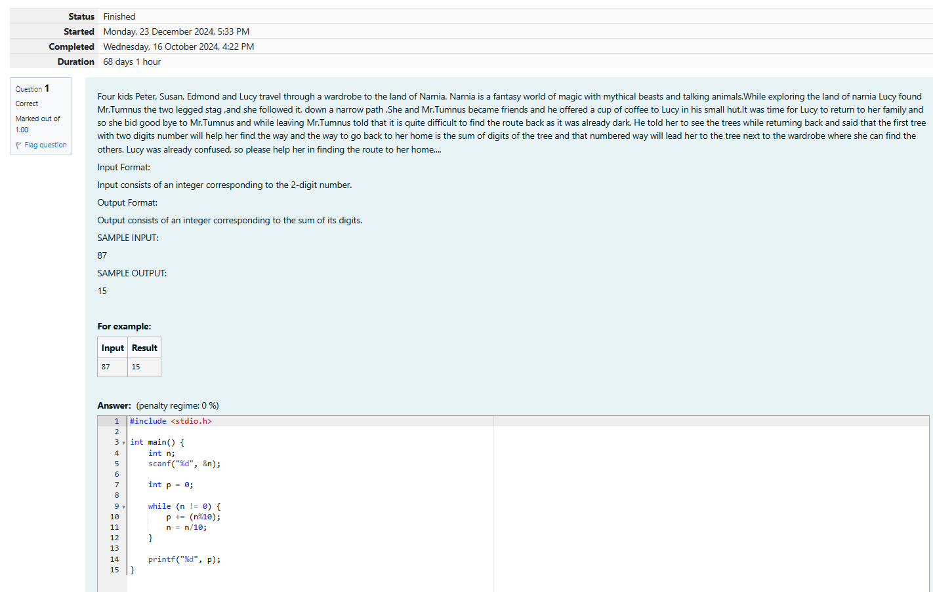

**Output:**

